
Group Assignment

Course: Business Intelligence for Data Science (880682-M-6)
Semester: Fall 2025/Block 2

Business Topic: Optimizing Theme Park Revenue

Contributors:
Kalina Dimitrova, 2065416
Linde Huijben, 2148970
Michelle Asmus, 2135406
Zahra Vafadar Nikjoo, 2131978
Komal Kainth, 2144763

CONTENT:
1. Describe motivation and goals for building DW into an enterprise of choice – 2 points.
2. Create and describe the OLTP schema with relationships, entities and attributes with screenshots and submit the file of the model (.mvb file) – 2 points.
3. Transfer the OLTP schema diagram into Tables in MySQL and load with the .csv files – 2 points.
4. Create and transfer DW schema into Tables in MySQL – 2 points.
5. Describe the dimensions and fact for the DW and chosen variant, i.e. star/snowflake/constellation with screenshots and submit the file of the model (.mvb file) – 2 points.
6. Describe and present (both with screenshots and by submitting the .ktr files) three ETL processes used for transformations (more details in Section 6) – 6 points.
7. Create and present one View (both with screenshot and by submitting the file) using some of the keywords (more details in Section 7) – 2 points.
8. Create and present one Report (both with screenshot and by submitting the file) – 2 points.

1. Motivation & Goals
We decided to use (generated) theme park data to design a data warehouse for monitoring sales within the park. A data warehouse enables the integration of sales data from multiple sources, the storage of historical information and the analysis of trends across time, locations, and visitor segments. This supports reliable reporting, performance monitoring and data-driven decision-making aimed at improving revenue and operational efficiency.
The primary objectives are to establish a single, consistent financial overview, identify sales trends over time, and gain insight into which locations and products drive revenue. Additionally, the data warehouse supports the creation of key performance indicators (KPIs) and management dashboards, facilitating improved operational decisions.
Specific analytical use cases include monitoring revenue trends, analyzing sales volumes and profitability, assessing the impact of discounts and promotions, and evaluating food and ticket purchases to identify underperforming attractions or outlets. By designing a star schema with time and visitor dimensions, the data warehouse simplifies complex analytical queries for operations and finance teams while keeping ETL processes manageable. Ultimately, this approach supports operational KPIs, targeted marketing strategies, and long-term strategic planning.

2. Source OLTP schema
The OLTP schema for the theme park includes seven main tables: visitor, ticket, ride, location, employee, ridelog, food_order. Each table has a primary key to ensure unique identification, and foreign keys establish relationships between them. Visitors store details about park visitors and are linked to tickets, ridelogs, and food orders, as a visitor can buy multiple tickets, ride multiple rides, and place multiple food orders. Tickets record ticket purchases and reference the visitor who bought them. Rides contain ride information and are assigned to a location; each ride can have many ride logs. Locations represent park zones and connect to rides, employees, and food orders. Employees work at specific locations and can manage rides or process food orders. Ridelogs track individual visitor rides, linking rides, visitors, and employees. Food orders track visitor purchases and reference visitors, employees, and locations. Overall, the schema captures all operational and transactional data, ensuring data integrity and establishing clear one-to-many relationships, providing a strong foundation for the data warehouse.
A full attribute dictionary describing all entities and fields in the OLTP schema is provided in Appendix A.
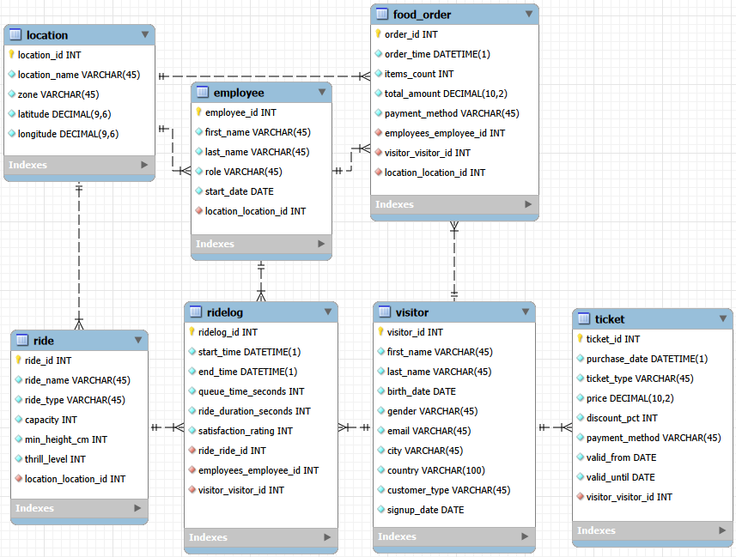
Figure 1. OLTP schema Theme Park

3. Transferring OLTP schema to Tables in MySQL
The OLTP schema designed in MySQL Workbench was transferred into MySQL as physical tables. Each table from the schema (visitor, ticket, ride, location, employee, ridelog, food_order) was created with the appropriate data types and primary/foreign key constraints to maintain referential integrity.
The data from the corresponding CSV files was loaded into each table using MySQL’s import wizard, ensuring that all records, data types, and relationships were preserved. After successful data import, sample rows were queried to verify accuracy. For the assignment, screenshots of the table structure and the first few rows were captured to demonstrate that the tables were created correctly and populated with data.
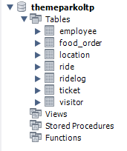
Figure 2. Transferring the OLTP into Tables
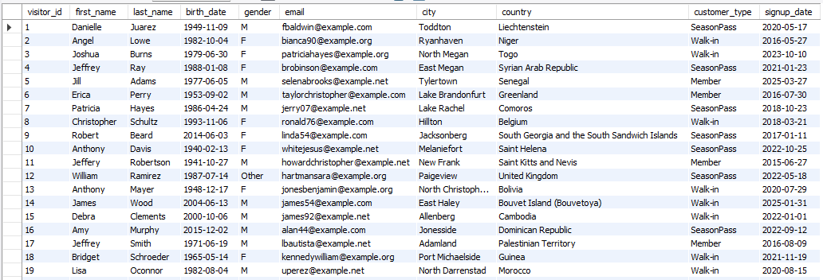
Figure 3. Imported data for visitor table
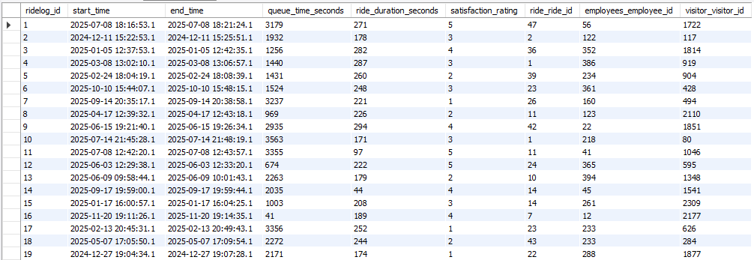
Figure 4. Imported data for ridelog table

4. DW schema
The Data Warehouse schema was created in MySQL by translating the dimensional model into physical tables. All dimension tables (dim_product, dim_time, dim_person) and the central fact table (fact_sales) were implemented with primary keys, foreign keys, and appropriate data types following the star-schema structure. After creating the tables, the structure was validated to ensure referential integrity and consistency, preparing the database for ETL population
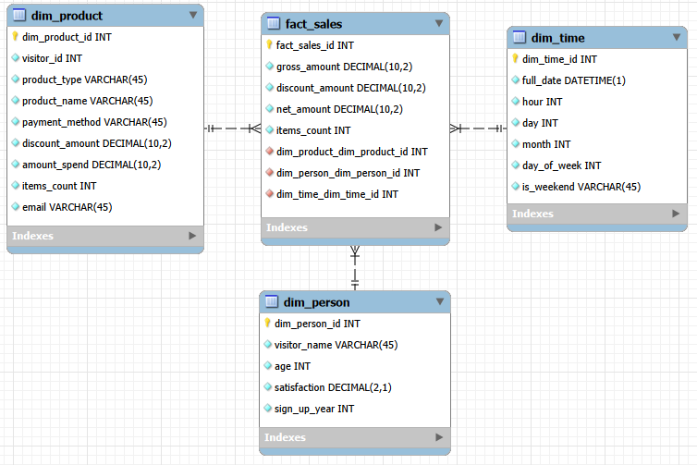
Figure 5. DW schema for Theme Park
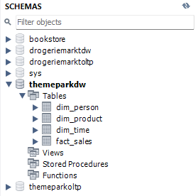
Figure 6. Transferring the DW into Tables

5. Dimensions & Facts of DW
The core of the Data Warehouse is the fact_sales table, which captures the key quantitative measures needed for analysis. The fact table stores four main metrics: gross_amount, discount_amount, net_amount, and items_count. These were chosen because they directly support the business questions the warehouse is meant to answer, such as revenue trends, discount impact, sales volume, and profitability. The net amount is especially important, as it is derived from the gross and discount amounts, and will be computed and validated during the ETL transformations.
The fact table links to three dimension tables through surrogate foreign keys, allowing each sale to be analyzed from different angles. The dimensions are intentionally minimal:
- dim_product (basic product identifiers),
- dim_time (date and basic calendar info),
- dim_person (simple customer profile),
These dimensions provide just enough descriptive context to slice the fact measures without overcomplicating the schema, which also keeps the ETL transformations focused and efficient.
The model uses a star schema, chosen for its simplicity, fast query performance, and clear separation between numeric facts and descriptive dimensions. This structure aligns well with the planned transformations, where data from the OLTP system will be cleaned, joined, and loaded into a denormalized central fact table surrounded by straightforward dimensions.

6. ETL transformations in Pentaho Data Integration
Below you will find the ELT-transformations with additional explanations.
Transformation dim_product:
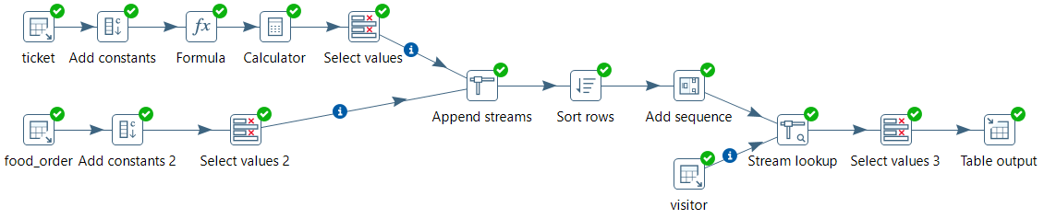
Figure 7. Dimension Product Transformation
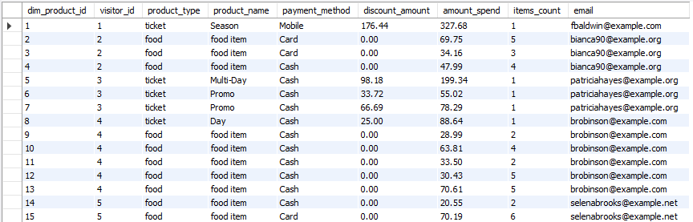
Figure 8. Dimension Product in MySQL

Description:
The dim_product transformation integrates two (seperate) OLTP sources - ticket purchases and food orders - into a combined product dimension that is used to describe all purchasable items in the theme park. Seeing that tickets and food items originate from different structures, the transformation focuses on standardizing both datasets and enriching them with additional attributes to generate a consistent dimensional output.
The process begins with the ticket table, since ticket purchases do not inherently include product classification or item count, two constants are added to standardize the structure. A product_type field set to ‘ticket’ and an item_count fixed at 1, because each ticket corresponds to a single transaction line.
The discount_pct value is stored as a whole number (e.g., 15 for 15%). To calculate the correct discount amount, Pentaho must convert it into a decimal. The Formula step divides the value by 100, so 15 becomes 0.15. This ensures the Calculator step can correctly compute the discount amount. Building on this, a Calculator step computes the actual discount amount by multiplying the base price by the converted percentage. After these transformations, a Select Values step separates only the relevant fields needed later for merging, ensuring the stream is streamlined and consistent.
In parallel, the transformation also follows the sequence from the food_order table. Unlike ticket purchases, food order rows do not include product-specific fields such as product name or discount. To harmonize the schema, constants are added: product_type set to “food”, product_name set to “food_item”, and discount_amount set to 0 because no discounts apply. A Select Values step prepares a clean subset of columns that match the structure of the ticket stream.
Once both input streams are standardized and Append Streams step vertically merges them into a single dataset. This creates a combined recordset where every row—whether representing a ticket or a food item—follows a uniform schema, enabling unified dimensional modeling. After merging, a Sort Rows step orders the records by visitor_id and order_time to ensure consistent sequencing and prepare the data for surrogate key assignment.
An Add Sequence step then generates a surrogate primary key (dim_product_id) for each record, which will serve as the dimension key in the data warehouse. By adding the visitor table as an input stream, the dataset is enhanced, and each product record is matched with the corresponding visitor email address via a Stream Lookup .In this project’s context, this lookup was included to support the business logic of linking a purchase to a visitor’s contact information, for example to enable email communication or confirmations. The focus of this transformation is to create a consistent and complete description of each product, rather than performing analytical calculations
Finally, a Select Values step reorders and renames the resulting fields to align with the target dimensional schema. The completed rows are then written to the data warehouse through a Table Output step, producing the final dim_product table. The output confirms that ticket purchases and food orders have been fully standardized, enriched, and merged into a single, consistent dimension suitable for analytics.

Transformation dim_person
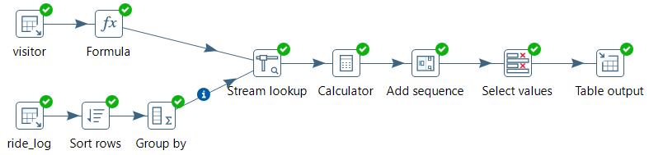
Figure 9. Dimension Person Transformation
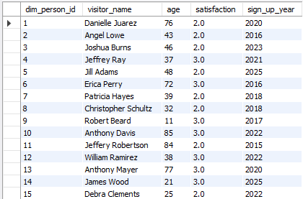
Figure 10. Dimension Person in MySQL
Description:
The dim_person transformation builds a visitor dimension that combines demographic data from the ‘visitor’ table with behavioral data from the ‘ridelog’ table. The aim is to create one clean, enriched record per visitor that captures both who the visitor is and how they interact with the theme park.
The transformation begins by reading data from the ‘visitor’ table. A Formula step is used to concatenate the ‘first_name’ and’ last_name’ into a single ‘visitor_name’ attribute. The same step also calculates each visitor’s age based on the difference between the ‘current year’ and their ‘birth_date’. These derived fields help simplify later analysis and reporting.
In parallel, the ‘ridelog’ table is loaded to obtain satisfaction information. Since each visitor can appear multiple times in ‘ridelog’, the stream is first sorted by ‘visitor_id' and then aggregated using a Group By step. This produced a single satisfaction score per visitor, defined as the average satisfaction rating across all rides they participated in. The result is a compact dataset, one row per visitor that summarizes their overall ride experience.
A Stream Lookup step then enriches the visitor dataset by joining in the calculated satisfaction score, the join is performed on ‘visitor_id’, ensuring that each satisfaction value aligns with the correct visitor record. If a visitor does not appear in ‘ridelog’ (for example, they bought a ticket but did not go on any rides), the lookup assigns a null of configured default value.
Next, a Calculator step derives ‘sign_up_year’ from ‘signup_date’. This supports time- based analyses in the Data Warehouse, such as tracking customer acquisition by year and studying the behavior of new members. The data is then sorted by 'sign_up_year’ to keep the stream consistent before assigning surrogate keys.
An Add Sequence step generates the surrogate primary key ‘dim_person_id’ for the dimension table. This surrogate key uniquely identifies each visitor in the Data Warehouse and functions as a stable, non-business identifier that can be referenced by fact tables.
Finally, a Select Values step renames and orders the fields to match the dimensional schema, retaining only the required output columns: `dim_person_id`, `visitor_name`, `age`, `satisfaction`, and `sign_up_year`. The resulting dataset is written to the Data Warehouse using a Table Output step, producing the `dim_person` table referenced in the results screenshot.

Transformation dim_time
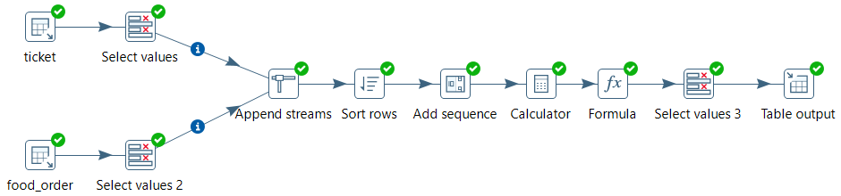
Figure 11. Dimension Time Transformation
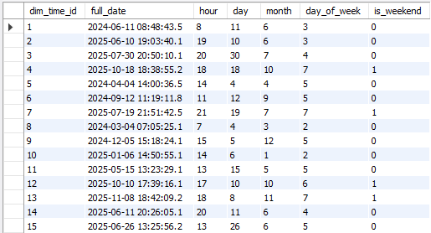
Figure 12. Dimension Time in MySQL

Description:
The dim_time transformation creates a unified time dimension that captures all relevant timestamps associated with purchases and sales in the themepark. Since both ticket sales and food orders represent customer transactions happening at different times, the goal is to consolidate the timestamps into one dimension table.
The transformation begins by reading from the ticket table. The Select Values step keeps only the required fields where ‘purchase_date’ is renamed to ‘order_time’ and ‘visitor_id’. This way there is consistency across both transaction streams. The food_order table is also loaded and through Select Values order_time and ‘visitor_id’ are extracted. This also ensures that both streams now share identical field names which will help enable a clean merge later.
For the next step, Append Streams, the two previous streams were vertically merged. This produced a unified dataset where each row represents a timestamped customer action regardless of purchase item. The Sort Rows step orders the combined stream by ‘visitor_id’ and ‘order_time’. This ensures that the time dimension remains consistent.
A primary key ‘dim_time_id’ is generated by the Add Sequence step. This identifier links the time records to the fact table. The next step, Calculator, is used to extract the following time attributes from ‘order_time’: ‘hour’, ‘day’, ‘month’ and ‘day_of_week’. These fields will later help when slicing or report on trends such as busiest hours and monthly sales. With the Formula step, the attribute ‘is_weekend’ is created by setting it to 1 if ‘day_of_week’ is Saturday(6) or Sunday(7) and otherwise to 0. This metric will also allow us to compare trends during weekdays vs weekends.
To prepare for the output, Select Values is used to remove fields that are unnecessary and the final schema is arranged to match the DW target; ‘dim_time_id’, ‘full_date’, ‘hour’, ‘day’, ‘month’, ‘day_of_week’ and ‘is_weekend’. Finally, the finished dimension is written into the DW as dim_time using Table Output. The resulting table, dim_time, is shown in Figure 12.

Transformation fact_sales
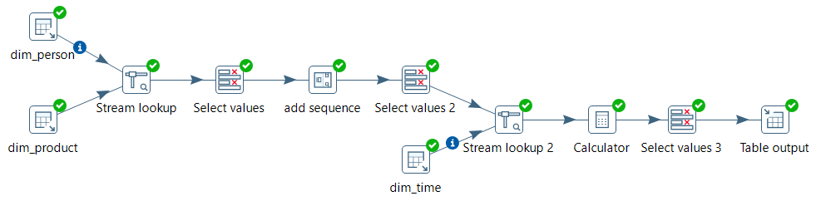
Figure 13. Fact Sales Transformation
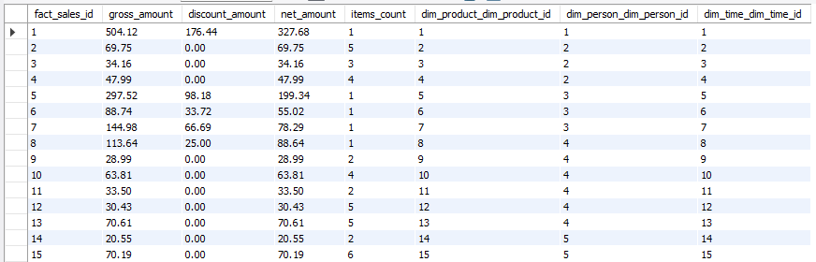
Figure 14. Fact Sales in MySQL

Description:
The final transformation, fact_sales, builds the central fact table of the DW by combining measures and foreign keys from the different dimensions. The goal is to create one record per sale that links to the product, person, time dimension and stores the key financial metrics such as gross, net and discount amounts. The transformation starts by reading from the dim_person table which contains the ‘dim_person_id’ key that will be used to add remaining information. Next, the dim_product table is loaded which contains important keys such as ‘net_amount’, ‘discount_amount’, ‘items_count’ and ‘dim_product_key’. The Stream Lookup step is used to join ‘dim_product’ onto the ‘dim_person’ stream by matching records by shared identifiers; ‘visitor_id’ and ‘dim_person_id’. The next step, Select Values, selects the fields that are relevant for the fact table and leaves out unnecessary fields. The Add Sequence step assigns a surrogate key ‘fact_sales_id’ to each row. This will be the primary key of the fact_sales table. The transformation then reads from the dim_time table which provides the time dimension key ‘dim_time_id’ and the associated timestamp attributes. A second Steam Lookup step is used to attach the appropriate ‘dim_time_id’ to each sales row by matching on the corresponding timestamps. After this step, every sale is linked to ‘dim_product_id’ and ‘dim_time_id’. The Calculator is then used to calculate ‘gross_amount’ based on ‘net_amount’ and ‘discount’. This ensures that all financial measures are available and consistent for reporting and analysis purposes. Another Select Values is used to select the final fields for the fact table and order and rename them to match to the target DW schema. The resulting table includes the following fields; ‘fact_sales_id’, ‘gross_amount’, ‘discount_amount’, ‘net_amount’, ‘items_count’, ‘dim_product_id’, ‘dim_person_id’ and ‘dim_time_id’. Finally, the Table Output step writes the selected fields into the fact_sales table in the DW. The resulting fact table, see Figure 14, links all transactions to their respective dimensions and provides the core financial information needed to analyze revenue, discounts and sales volume across products, customers and time.

7. View in MySQL
For the SQL view, a view was created to calculate the average customer satisfaction for young adults between the ages of 20 and 40. This view demonstrates a slicing operation, where data is filtered on a single dimension attribute in this case, visitor age. The query groups the results by age and computes the average satisfaction score for each age within the selected range.
The SQL code used to generate the view is shown below, followed by the resulting output. The corresponding .sql file is included in the submission package.

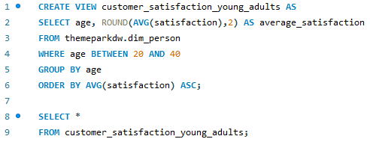
Figure 15. View that contains average customer satisfaction from young adults (age 20-40).
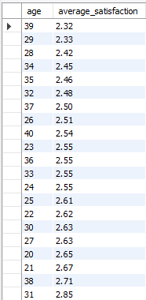
Figure 16. View result.

8. Report in Pentaho Report Designer
The revenue report displays the total cash flow per product, summarizing three key financial measures: total discount, total gross revenue and total net revenue. The report is organized by product_name, which includes the various theme park ticket types (Day, Multi-Day, Promo, Season) as well as food item purchases. This structure allows a straightforward comparison of revenue performance across different product categories.
The screenshot below shows the final report output generated in Pentaho Report Designer, and the corresponding .prpt file is included in the submission package.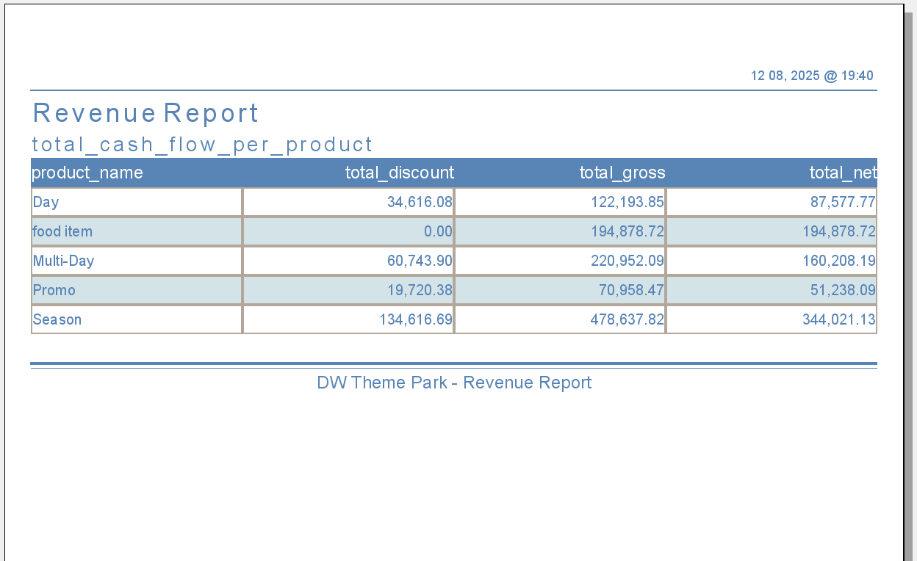
Figure 17. Report result

Appendix A

OLTP Dictionary

Table 1. Location
Attribute | Type | Key | Description
location_id | INT | Primary Key | Unique ID for each park location..
location_name | VARCHAR(45) | - | Name of the location (e.g., Water World).
zone | VARCHAR(45) | - | Logical region: North/South/East/West.
latitude | DECIMAL(9,6) | - | Geographic coordinate
longtitude | DECIMAL(9,6) | - | Geographic coordinate

Table 2. Visitor
Attribute | Type | Key | Description
visitor_id | INT | Primary Key | Unique ID for each visitor.
first_name | VARCHAR(45) | - | Visitor’s first name
last_name | VARCHAR(45) | - | Visitors last name
birth_date | DATE | - | Used to compute age and age group
gender | VARCHAR(45) | - | Gender of the visitor (M/F/Other)
email | VARCHAR(100) | - | Contact email: used for identification and marketing purposes.
city | VARCHAR(45) | - | Visitor’s home city
country | VARCHAR(100) | - | Visitor’s home country
customer_type | VARCHAR(45) | - | Type of customer (Walk-in, Member, SeasonPass )
signup_date | DATE | - | When the visitor registered or purchased the first ticket.

Table 3. Ride
Attribute | Type | Key | Description
ride_id | INT | Primary Key | Unique ID for each ride.
ride_name | VARCHAR(45) | - | Name of the ride.
ride_type | VARCHAR(45) | - | Thrill, Family, Kids, Water, etc.
capacity | INT | - | Max number of riders per session.
min_height_cm | INT | - | Minimum height requirement.
thrill_level | INT | - | Rating 1–5 indicating intensity.
location_location_id | INT | Foreign Key | Zone where the ride is located.

Table 4. Employee
Attribute | Type | Key | Description
employee_id | INT | Primary Key | Unique ID for the employee
first_name | VARCHAR(45) | - | Employee's first name.
last_name | VARCHAR(45) | - | Employee's last name.
role | VARCHAR(45) | - | Role of the employee (Operator, Barista, Cashier, Supervisor, etc.).
start_date | DATE | - | Employment start date.
location_location_id | INT | Foreign Key | Primary location of work.

Table 5. Ticket
Attribute | Type | Key | Description
ticket_id | INT | Primary Key | Unique ticket purchase ID.
purchase_date | DATETIME(1) | - | When the ticket was purchased.
ticket_type | VARCHAR(45) | - | Ticket type (Day/Multi-Day/Season/ Promo)
price | DECIMAL(10,2) | - | Base price before the discount.
discount_pct | INT | - | Discount percentage applied to ticketprince
payment_method | VARCHAR(45) | - | Payment type (e.g .Cash/Card/Mobile payment)
valid_from | DATE | - | Start of ticket validity.
valid_until | DATE | - | End of ticket validity.
visitor_vistor_id | INT | Foreign Key | Visitor’s ID who bought the ticket.

Table 6. Food order
Attribute | Type | Key | Description
order_id | INT | Primary Key | Unique ID for each food order transaction
order_time | DATETIME(1) | - | Timestamp of the food order.
items_count | INT | - | Number of items included in the order.
total_amount | DECIMAL(10,2) | - | Total purchase amount.
payment_method | VARCHAR(45) | - | Payment method (Cash, Card, Mobile).
employees_employee _id | INT | Foreign key | Employee who processed the order
visitor_vistor_id | INT | Foreign key | Visitor who placed the order
location_location_id | INT | Foreign key | Location of the food place where the order was made.

Table 7. Ridelog

Attribute | Type | Key | Description
ridelog_id | INT | Primary Key | Unique ID for each ride event
start_time | DATETIME(1) | - | Start time of the ride
end_time | DATETIME(1) | - | End time of the ride
queue_time-seconds | INT | - | Time the visitor waited in the queue (in seconds).
ride_duration_seconds | INT | - | Actual ride duration (in seconds).
statisfication_rating | INT | - | Visitor satisfaction rating (1–5).
ride_ride_id | INT | Foreign Key | Ride associated with this event.
employees_employee_id | INT | Foreign Key | Employee operating the ride.
visitor_vistors_id | INT | Foreign Key | Visitor who participated in the ride.

